QUIZ GAME APPLICATION
━━━ USING C++ ━━━

Subject Name | C++
Subject Code | 1501100180

Student Name | Roll Number
Bhaumikk Keer | 150096725030
Akhila Anish Das | 150096725016
Jaspreet Kaur Bassi | 150096725014
Lokendra Joshi | 150096725062

Course | BTech CSE 2025-2029
Cohort | Larry Page
Semester | Semester 2 - Sprint 1
Institution | ITM Skills University, Kharghar

1. INTRODUCTION
A Quiz Game Application is an interactive software program that tests users' knowledge through multiple-choice questions. It makes learning fun and engaging by providing instant feedback and automatic scoring.
Quiz applications are important because they make education interactive and help students learn faster. They provide immediate feedback, which helps students understand their mistakes and learn the correct answers right away.
2. PROBLEM STATEMENT
Traditional paper-based quizzes are time-consuming to grade, provide delayed feedback, and lack interactivity. Students need an automated system that can instantly evaluate their answers and provide immediate results. This Quiz Game Application solves this problem by automating the quiz process with instant feedback and automatic score calculation.
3. OBJECTIVES OF THE PROJECT
- To design a user-friendly quiz game interface
- To implement accurate answer validation and scoring
- To provide immediate feedback on answers
- To apply C++ programming concepts (structures, arrays, functions, loops)

4. SCOPE OF THE STUDY

What is Included:
- Multiple-choice questions with 4 options
- Instant answer validation
- Score calculation and display
- Console-based interface

What is Not Included:
- Graphical user interface (GUI)
- Database for storing questions
- User authentication system
- Timer functionality

Limitations:
- Questions are hardcoded in source code
- No persistent data storage
- Single player only

5. METHODOLOGY / DESIGN

System Flow:
- Program starts with welcome message
- Questions are stored in an array of structures
- Each question is displayed with options A, B, C, D
- User enters their answer
- System validates answer and shows feedback
- Score is calculated and displayed at the end

Key Algorithms:
- Display Question: Loop through options and display with labels
- Check Answer: Convert input to uppercase and compare
- Calculate Score: Count correct answers

6. TECHNOLOGY USED
Programming Language | C++
IDE / Software | Visual Studio Code
Hardware | MacBook (macOS)
Compiler | Clang++

7. IMPLEMENTATION DETAILS

How the System Works:
The quiz game has four main components that work together:
1. Question Structure: Stores each question with its 4 options and correct answer
2. displayQuestion() Function: Displays question and options labeled A, B, C, D
3. checkAnswer() Function: Compares user answer with correct answer (case-insensitive)
4. startQuiz() Function: Controls the entire quiz flow - displays questions, gets input, validates, and calculates score

C++ Concepts Used:
- Structures - To organize question data
- Arrays - To store multiple questions
- Functions - For modular code organization
- Loops - To iterate through questions
- Conditional Statements - For answer validation
- String Handling - For text processing
- Input/Output - For user interaction

Code Screenshots:
Source Code: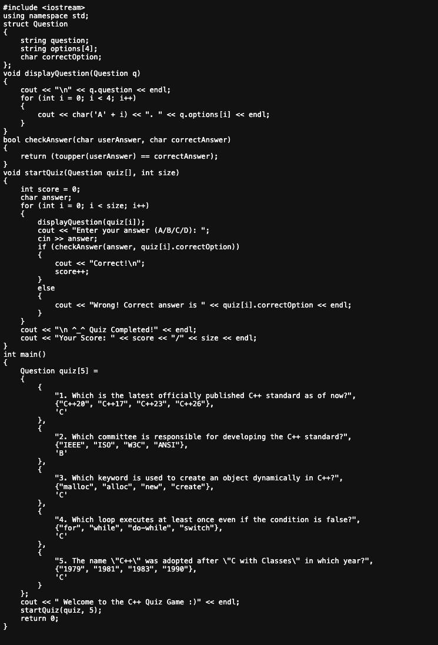
8. RESULTS AND OUTPUT
The application was successfully developed and tested. It displays questions correctly, accepts user input, validates answers, and calculates the final score.

Sample Input and Output:
Terminal Output Screenshot:
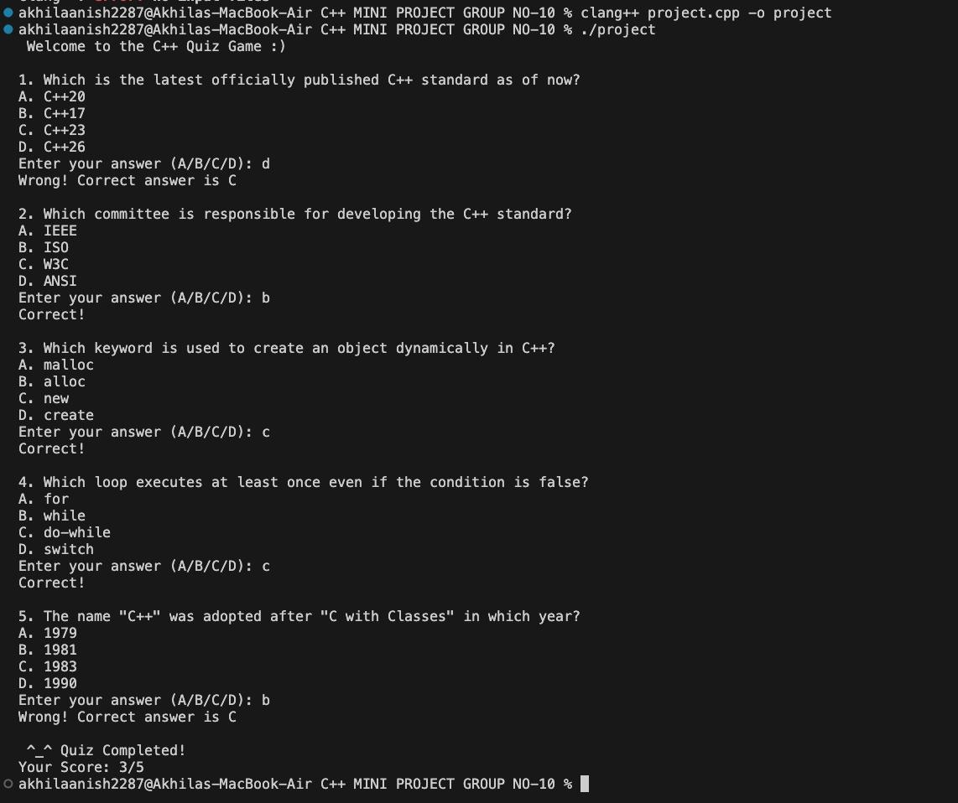

Performance Results:
- All user inputs are validated correctly
- Immediate feedback is provided after each answer
- Final score is calculated accurately
- All project objectives were successfully achieved

9. ADVANTAGES
- Easy to use - Simple console interface
- Time-saving - Automatic grading
- Cost-effective - No additional software needed
- Accurate results - No human error
- Instant feedback - Learn immediately
- Educational - Helps in learning C++ concepts

10. LIMITATIONS
- No graphical user interface
- Questions are hardcoded in source code
- No database integration
- Single player mode only
- No timer or difficulty levels
- Cannot track progress across sessions

11. FUTURE ENHANCEMENTS
- Add graphical user interface (GUI)
- Implement database for storing questions and scores
- Add user login and profile system
- Include timer for each question
- Add different difficulty levels
- Implement question randomization
- Create leaderboard system
- Add more question categories

12. CONCLUSION
The Quiz Game Application project was successfully completed. It demonstrates practical application of C++ concepts including structures, arrays, functions, and loops. The application provides an interactive way to test knowledge with instant feedback and automatic scoring.
13. REFERENCES
- Let Us C++ by Yashavant Kanetkar
- W3Schools C++ Tutorial (https://www.w3schools.com/cpp/)
- GeeksforGeeks C++ Programming (https://www.geeksforgeeks.org/c-plus-plus/)

© Coding done by Everyone

